NEKTA MANAGEMENT SYSTEM

NAME: KIMANI LAWRENCE MACHARIA

SCHOOL CODE:1120001

INDEX:357

SCHOOL: ALLIANCE HIGH SCHOOL

YEAR:2022

# DEDICATION

I would like to dedicate this project to my loving family which has persistently provided encouragement and offered prayers all along. I would also like to dedicate it to my able teacher

# ACKNOWLEDGEMENT

I would like to acknowledge my computer studies teacher for guiding me through the process of coming up with the project, the school administration for availing the resources for the completion of the project, my fellow students for their moral support and encouragement throughout the period of constructing the project.

# TABLE OF CONTENTS

Contents

DEDICATION 2

ACKNOWLEDGEMENT 3

TABLE OF CONTENTS 4

LIST OF FIGURES AND TABLES 5

INTRODUCTION 6

CHAPTER 2 7

PROBLEM DEFINITION 7

**PROPOSED SYSTEM** 7

Advantages of the new system 8

Disadvantages of the new system 8

2.1 FACT FINDING 11

2.4.1 Procedure 11

2.4.2 Finding 13

2.2 SYSTEM REQUIREMENTS SPECIFICATIONS 15

CHAPTER 3: SYSTEM DESIGN 16

3.1.1 General system flowchart 17

DETAILED DESIGN 21

INPUT DESIGNS 23

# LIST OF FIGURES AND TABLES

Figure 1: Sample of Interview Template 12

Figure 2: Sample of Employee Questionnaire 13

Figure 3: General system flowchart 17

# INTRODUCTION

Nekta is company that deals with beekeeping and selling of honey. The company offers services like:

* Selling of beehives and associated accessories to bee farmers;
* Setting up of the beehives for the bee farmers;
* Offering of training on bee keeping;
* Buying of honey related products from farmers

The project is meant to develop a computerized system for the company to automate its records and services.

The project is database management system capable of maintaining records of farmers and other information concerning the services the company offers. Using the current system is cumbersome and tiresome thus always prone to errors which cost the organization a lot of loss and time wastage.

# CHAPTER 2

## PROBLEM DEFINITION

The problem at hand is to develop a computerized based transaction processing system that would capture and process data about the company’s transaction. Currently, the company keeps its data manually. Increase in the number of customers has necessitated the company to adopt a computerized system to maintain its records.

The system should be able to:

1. maintain records of:

* bee farmers of the company
* trainee farmers
* payments for each package
* details of packages from farmers
* income from various sales and training services
* services rendered and products sold by the company

1. provide output in form of reports
2. compute all operations for each transaction

#### OVERVIEW OF THE EXISTING SYSTEM

The existing system is a manual system where records of all other transactions are recorded manually. All calculations are done by calculators. The output is in form of sheets having the records.

## **PROPOSED SYSTEM**

#### OVERVIEW OF PROPOSED SYSTEM

The computerized system has been proposed to solve the current problems facing the company. This system will be effective as it utilizes computer aspects such as memory. The many problems faced will be solved by the new system.

#### OBJECTIVES OF THE NEW SYSTEM

* Reduce the rate of irregular data being received
* Perform all operations on the transactions and produce accurate output
* Reduce amount of money of money used to buy manual storage media
* Increase the lifespan of the data of the company

### Advantages of the new system

The new computerized system has many advantages that outweigh the current manual system in that, the new system:

* Is faster and more reliable. There is faster processing of data during the registration of bee farmers, calculation of purchases and delivery of services. Very few hitches are bound to occur.
* Achieves high data integrity. Data that is fed into the information system passes through a series of integrity rules and checks to ensure that the data stored is valid and necessary.
* Ensures time is saved. The new system consists of various lookup wizards and fields which guide the user during data entry and manipulation which serve to provide frequently entered data which makes it easier to register a new farmer or trainer.
* Ensures detailed summary reports are easily generated. High quality reports that may show trends and emerging issues are easily generated without any manual calculations.
* Achieves saving on profits realized by the company. The system does not require more than two workers to run it, thus most of the company’s profits are saved, since less workers are required to run the system.
* Improves work efficiency of the workers. The workers are able to perform tasks in their tasks faster and improve delivery of services.

### Disadvantages of the new system

* High operational costs are involved. The system requires a constant supply of electricity and resources such as printer papers to make the system work. System specialists who maintain the system are also required to ensure that normal operations run out as normal without any errors.
* The system is prone to breakdowns. This may be brought about by logical errors. However, the hitches are rare. The breakdowns may lead to huge data losses if immediate action is not taken. This can easily be avoided by backing up the data in the system.

#### Schedule feasibilty

To ensure that the system is put in place as soon as possible for the company, the following schedule was carefully planned to come up with the Information System in time.

|  |  |
| --- | --- |
| **Activity** | **Duration** |
| Problem Recognition and Definition | 1 month |
| System analysis | 1 month |
| System Design and Construction | 3 months |
| Implementation and testing | 1 month |
| System Review and maintenance | 1 month |
| **Total Duration** | 7 months |

Table 1: Computerized System Schedule Feasibility Study

The schedule will ensure that the Nekta Management System is made effective fast in order to improve operations in the company.

#### 2.3.6.2 Technical feasibility

Most workers are conversant with the technology required to develop and run the system. However, there is need in the company to upgrade the current system infrastructure and capacity to use and support the new system. Some of the technologies required are:

**Hardware resources** such as, a computer and a storage media.

**Software resources:**

* Database management system, for example, Microsoft Access
* Up-to-date Antivirus software, for example Kaspersky Antivirus.

#### 2.3.6.3 Economical feasibility

The cost of the development and implementation of the proposed system is estimated as follows:

|  |  |
| --- | --- |
| ***Estimated costs*** | |
| **Category** | **Total Cost (KSh)** |
| Development Cost | 500,000 |
| Maintenance Cost | 50,000 |
| Monthly Operation Costs | 20,000 |
| Ream Papers for reports | 15,000 |
| **TOTAL** | **585,000** |

Table 2: Estimated costs for proposed Computerized System

|  |  |
| --- | --- |
| ***Benefits*** | |
| **Category** | **Total Cost (KSh)** |
| Cost saved from correct account of data | 900,000 |
| Cost saved on material equipment | 100,000 |
| Profits from increased number of clients | 2,400,000 |
| **Total saved** | 3,400,000 |
| **Profits from the system** | **2,815,000** |

Table 3:Estimated benefits from the proposed computerized system

#### 2.3.6.4 Operational feasibility

The system is designed using a graphical user interface (GUI) hence it is interactive and user-friendly. This makes it easy to use and will increase the work efficiency of the workers and enable them to utilize data accordingly. With sufficient training on the employees, the organization will be able to fully adapt to the redesign of the system within a week.

## FACT FINDING

### 2.4.1 Procedure

Necessary facts were needed to construct the entire database system. The facts to be gathered include the terminology used inside the company, problems encountered in the current system and necessary constraints on the data and users of the new system and the requirements of the new system.

The data gathering mission was fulfilled through:

1. Document review
2. Observation
3. Interviews
4. Questionnaires

#### 2.4.1.1 Document Review

A number of documents associated with the current system were viewed. These include forms, reports, inventory files, receipts, invoices, orders book, workbooks and ledger books. This gave a lot of insight on the current system and how it is operated. It is noted that there is a lot of data redundancy which needs to be depleted by the new system.

#### 2.4.1.2 Direct Observation

Observations were made on the employees of the company working with the current manual system. The information recording method and operation of calculations were observed. It was observed that data entry method was by use of a pen which was prone to a lot of errors, and operation of arithmetic was by a non-scientific calculator.

#### 2.4.1.3 Interviews

Interviews were planned to proceed on some of the five, randomly chosen employees. Conduction of one-on-one questioning of the employees by the interviewer was involved. The objectives of the interviews were to understand the operations of the current system. Each interview was proceeded for approximately 15 minutes. The answers given by the interviewee were written down by the interviewer in an interview template. The following is a sample of the interview template used during the interviews.

|  |  |  |
| --- | --- | --- |
| Time (minutes) | Interviewer Questions | Response |
| 1-2nd | Opening the interview   * Introduce myself * Ask interviewee’s name * Thank interviewee for his/her valuable time * State the purpose of the interview |  |
| 3-4th | For how long have you been in the company?  Are you satisfied with the current manual system being used in the company? |  |
| 5-7th | What are the conditions/qualifications for a farmer seeking services/products in the company?  How does the organization record its farmer’s information? |  |
| 8-9th | How long does it take for services and products to be delivered?  How can you evaluate the current manual system of the company? |  |
| 10-11th | What are the possible actions taken when a product/service is failed to be delivered?  How often are the complaints received from clients concerning product/service delivery? |  |
| 12-14th | Will the introduction of a computerized system in the company solve many problems?  Suggest improvements you would like to see in the new system. |  |
| 15th | Thank the interviewee for his/her cooperation. |  |

Interviewee Name: _________________________

Interviewer Name: _________________________

Date: _______________

Subject: ____________________________

Figure 1: Sample of Interview Template

#### 2.4.1.4 Questionnaires

The following sample of questionnaire was submitted to some of the employees in the company.

Figure 2: Sample of Employee Questionnaire

**QUESTIONNAIRE**

Date _____________

Nekta Company is in the process of finding out the effectiveness of the current system of running the college. The following questionnaire is designed to help the company gather your sincere opinion about the current system.

**INSTRUCTIONS:** Do not fill personal details on this paper for privacy purposes. Answer by ticking within a box and expound on answers where required.

1. How long have you been working with Nekta Management System?
2. On a scale of 1-10 how efficient is the current system? Explain your answer.

______________________________________________________________________________________________________________________________________________________________________________

1. Is there any need to change the system?

Suggest ways in which you think the system should be changed (Include features you would like to be added).

______________________________________________________________________________________________________________________________________________________________________________

1. How fast is the processing speed of the current system?

More than 4 years

Up to 4 years

1-6 months

### 2.4.2 Finding

Yes

No

Slow

Moderate

Fast

The fact-finding process revealed the real problems facing the current manual system. The research work was extensively done to ensure that a suitable system was implemented. The following are the findings obtained from the fact-finding process.

* The time taken to process a single entry for a farmer/client was about ten minutes for each client.
* There was a lot of redundancy of data and there was lack of data integrity during data input.
* The data kept has a very short lifespan of about 2-4 years since the physical storage space was insufficient hence old data had to terminated.
* No monthly and yearly reports of sales were done since it was almost impossible to keep track of all records in the current manual system.
* The time taken for orders to be delivered to clients was averagely, a week, most of the orders are mixed up or not delivered at all, due to ineffective maintenance of records.
* The filling forms were very confusing and not clear enough to the clients.
* Registration process of farmers took about 2 days, which made processing of orders very slow
* Most people concluded that introduction of a new computerized system will be of great use to the company.
* There was a jam during the control of service delivery and keeping of records.

In general, the response to the overview of the current system was negative and all respondents gave their opinion to change the outlook of the current system in regards to the following:

* Speed of data entry
* Duration of data processing
* Security and integrity of data entered
* Redundancy of the data entered.
* Summary of sales and orders after a certain time period.

## SYSTEM REQUIREMENTS SPECIFICATIONS

The minimum hardware and software requirements for the system to run efficiently are as follows:

**Software requirements**.

* Computer running Microsoft Windows 10 or above
* Microsoft Access application program
* Microsoft Word application program
* Kaspersky Antivirus Program (Latest Version)

**Hardware requirements**

* 50 GB of Hard drive space
* 5 GB RAM
* 3.1 GHz Dual Core Processor
* 22’’ LED monitor
* LaserJet ink printers
* CD/DVD drive

Some of the possible input, output and processing requirements needed for the system to function correctly are:

Input specifications

TBC

Processing specifications

TBC

Output specifications

TBC

# CHAPTER 3: SYSTEM DESIGN

#### OVERALL SYSTEM FLOWCHART

The following symbols were used in creating the system flowchart.

|  |  |
| --- | --- |
| **SYSTEM SYMBOL** | **MEANING** |
|  | FLOW DIRECTION |
|  | MANUAL INPUT |
|  | COMPUTERISED PROCESS |
|  | FILE STRUCTURE |
|  | TRANSACTION FILE |
|  | DISPLAY |
|  | DECISION |
|  | ON-PAGE CONNECTOR |
|  | INPUT |
|  | MANUAL PROCESS |
|  | OFF-PAGE CONNECTOR |
|  | AUTOMATIC PROCESS/EVENT |

*Table 4: Symbols used in system flowchart*

3.1.1 General system flowchart

*Farmer*

*Trainee*

**Validate entries**

**Validate entries**

Figure : General system flowchart

**Farmer details keyed in**

**Create farmer’s file**

**List of errors**

**REGISTRATION REQUEST**

**TRAINEE OR FARMER?**

**Trainee Details**

**Trainee details keyed in**

**Create trainee file**

**Farmer Details**

**List of errors**

**Trainer Details**

**Trainer details keyed in**

**List of errors**

**Create farmer’s file**

**Validate entries**

**NEKTA MANAGEMENT SYSTEM**

**Backup file**

**Generate report**

**List of members**

**Transport services**

**Customer Orders**

**Search customer**

**Allocate transport costs**

**Validation**

**Invalid**

**Update process**

**Transport file**

**Generate total transport costs**

**Invalid**

**Training services**

**Search trainee**

**Allocate trainer**

**Validation**

**Generate training schedule**

**Training schedule**

**Generate total training costs**

**Search customer**

**Order entry**

**Validation**

**Invalid**

**Update**

**Order file**

**Invoice**

**Generate total cost for products**

**Generate total cost for customers**

**Generate total sales for the company**

**Generate report**

**Invoice**

**Financial analysis**

**Generate total company income**

**Generate report**

**Report**

#### ENTITY RELATIONSHIP DIAGRAM

## DETAILED DESIGN

#### Tables

|  |  |  |  |
| --- | --- | --- | --- |
|  | TABLE NAME | FIELD NAME | DATA TYPE |
| 1 | FARMERS | Farmer ID (Primary Key)  First Name  Last Name  Address  Phone Number | auto number  text  text  text  text  text |
| 2 | TRAINERS | Trainee ID (Primary Key)  Trainee Name  Trainee Date Of Registration | text  text  date |
| 3 | SERVICES | Service ID (Primary Key)  Service Name  Service Cost  Service Unit | auto number  text  text  text |
| 4 | PRODUCTS | Product ID (Primary Key)  Product Name  Product Cost | auto number  text  text  currency |
| 5 | TRANSPORT | Transport Service ID (Primary Key)  Transport Service Type  Transport Cost  Service Unit | number  text  currency  text |
| 6 | SALES SERVICES TRANSACTION | Sales Service Transaction ID (Primary Key)  7Sales Service Date  Sales Service Quantity  Farmer ID  Service ID  Transport Service ID  Sales Service Distance | auto number  date  number |
| 7 | PRODUCT SALES TRANSACTION | Product Sales Transaction ID  Product Sales Date  Product Sales Quantity  Farmer ID  Product ID | auto number  date  number |

## INPUT DESIGNS

The forms will be used to capture data from the customers automatically hence saving time for the customers and the company too.

The form displayed below will be used to register new users and log in existing members

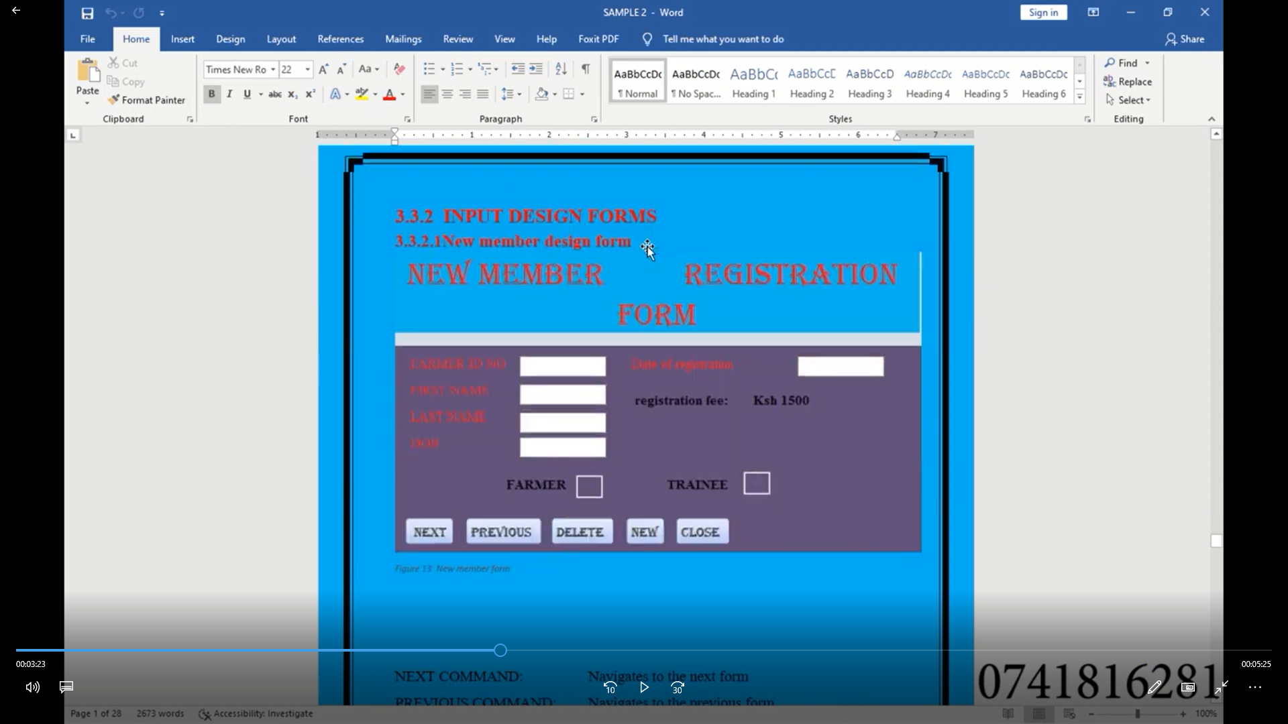

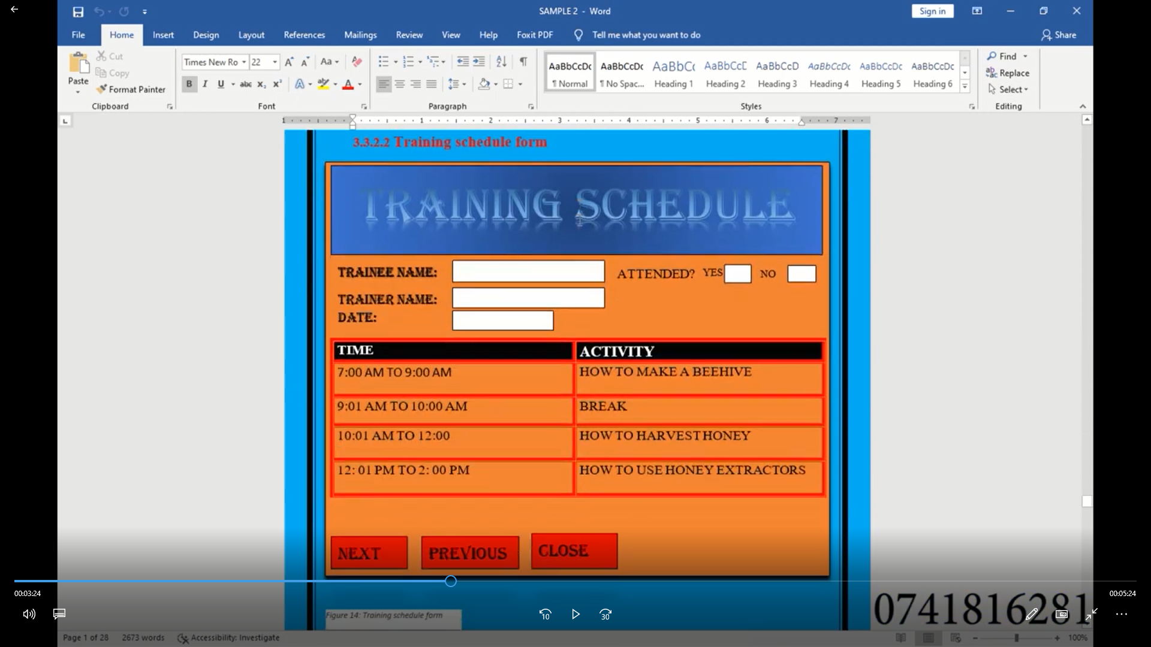

## OUTPUT DESIGN